SWITCHBOARD

USER DOCUMENTATION

As of: March 2024

CONTENTS
SWITCHBOARD 2
  - User interface 2
  - Logging in or out of queues. 2
  - Manage calls 3
  - Colored markers for queues 6
  - Change language & Exit 6

- SWITCHBOARD

SWITCHBOARD is an extension of Enreach Contact and provides an environment for clear call management.
SWITCHBOARD mainly serves receptionists, telephone operators and contact center teams that have direct customer contact.
SWITCHBOARD offers the following functions, among others:
- Overview of all calls in queues
- Switching between multiple calls
- Forward calls with just one click via the contact list
- Parking of calls and resumption
- Logging in and out of queues
This manual describes the user-based application of SWITCHBOARD. For queue administration, see the Enreach Contact documentation.

USER INTERFACE
The SWITCHBOARD interface can be accessed via the Enreach Contact Desktop Client under Menu | Queue Tools | SWITCHBOARD.

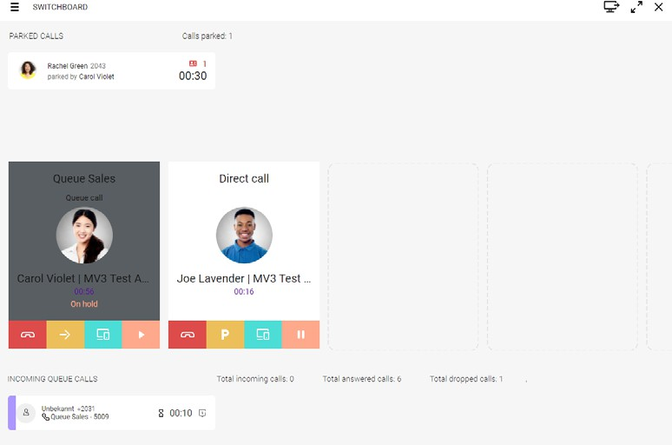
The user interface of SWITCHBOARD is divided into three parts:
    - In the upper part, all calls parked within the Privacy Group associ-ated with you are displayed
    - In the middle part all currently active, held and incoming calls are displayed
    - In the lower part, all incoming calls to queues to which you are logged in are displayed

LOGGING IN OR OUT OF QUEUES
You can log in or out of queues via the Enreach Contact desktop client or via the SWITCHBOARD interface.

To log in or out at queues over SWITCHBOARD
- On the SWITCHBOARD user interface, click on .
  - The Queue Selection opens.
- Select the respective queue to which you want to log in or log out by dragging the respective slider to the right (logged in) or left (logged out).
  - You are logged in or off at the respective queue.
Signaling of calls in a queue is done according to the configuration set for this queue. For further information see the Managed Voice 3 documenta-tion.

MANAGE CALLS
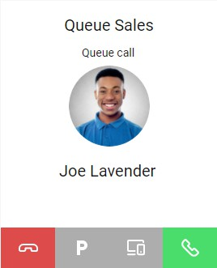
Incoming calls are signaled directly or via a queue and displayed on the SWITCHBOARD interface.
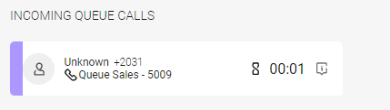
You can answer the call  or reject it  .

After you answer a call, you have several options to choose from.
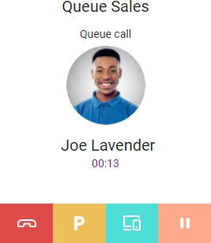
You can end the call .
You can park the call  .

You can transfer the call to another device . You can put the call on hold .

Use the Hold function to temporarily interrupt the connection to the caller. Use the Park feature to store the call in another location in the system so that other people can pick it up without the original recipient having to connect.

To park calls and resume parked calls
To park and resume calls, you need the Call parkingpermission. For further information see the Managed Voice 3 documentation.
- During an active call, click .
  - The call is parked on the corresponding line. The call is displayed as parked in the upper part of SWITCHBOARD and can be picked up.
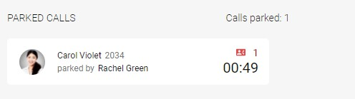
With an active call, use the key combination Ctrl + line number (e.g. Ctrl 1) to park the call directly on the corresponding line.

- Click on the parked call in the upper part of the SWITCHBOARD interface.
  - The connection is established again.
- Click on .
  - The previously parked call is active again and you can talk to the caller.

To transfer a call to another end device
To transfer calls to another device, e.g., a mobile phone or desk phone, the respective requirements must be met. You must be logged into Enreach Contact Mobile Mobile or a desk phone must be set up for you. For further information see the Enreach Contact Mobile documentation.
- During an active call, click the currently selected device .
  - The available devices are displayed.
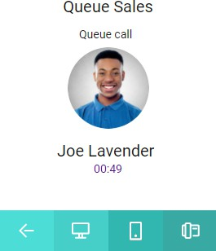
- Click on the device to which you want to transfer the call.
  - The selected device rings.
- Answer the call on the ringing device.
  - You can continue the call via the device.
The call screen remains visible in the middle part of the SWITCHBOARD interface, even if you make the call from another device. You can still end, park, transfer, put on hold, and switch devices via the SWITCHBOARD inter-face.

To switch between two calls
You have one or more calls on hold and one active call on your SWITCH-BOARD interface.

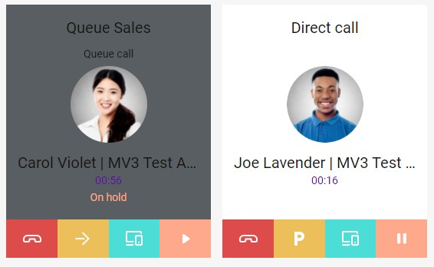
1 On the call screen of the call on hold, click  .
  - The active call is automatically put on hold and the previously held call becomes active.

Forward calls
You have several options to forward calls:
- Transfer active call without consultation (Blind Call Transfer)
- Start transfer with consultation

To forward a call with consultation
You have an active call and want to forward it with consultation.
- Click to put the active call on hold.
- Open the Enreach Contact Desktop Client and select the contact list
.
- Move the mouse over the contact you want to transfer the call to.
- Click on to show more options.
- Click on to call the contact.
  - You can consult with the subscriber to whom you are transferring the call.
- Click on  .
  - The call is forwarded to the selected contact and your connection with both callers will be terminated.

To forward a call without consultation
You have an active queue call and want to transfer the call without con-sultation.
- Open the Enreach Contact Desktop Client and select the contact list
.
- Move the mouse over the contact you want to transfer the call to.
- Click on 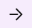 .
  - The call is forwarded directly to the contact.

COLORED MARKERS FOR QUEUES
For a better overview, you can mark the queues you are logged in to with up to four different colors. The colored marking shows you at which queue a call is received.

To define the colored markers for queues
- On the SWITCHBOARD user interface, click on .
  - The Queue Selection opens.
- Select a color next to the activated queue by clicking on one of the
arrows 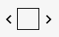 .
  - A call to the respective queue is marked with the selected color.
Example: With the following selection, a call to this queue is displayed accordingly:
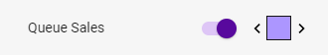
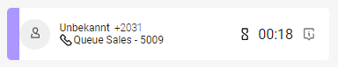

CHANGE LANGUAGE & EXIT
You can change the language in SWITCHBOARD via Enreach Contact. To close the SWITCHBOARD interface, click .

To change the language
- In the Enreach Contact Desktop Client select | Settings | Language.
- Select your desired language from the drop-down list.
- Click on Save.
  - The language of SWITCHBOARD and Enreach Contact is changed.

Closing SWITCHBOARD does not automatically log you out of all queues. See
To log in or out at queues over SWITCHBOARD, page 3.

